Web Programming I. Homework Documentation

Marvel Movie Database

The Webbape: <http://mmovies.nhely.hu/>

username:

ftp usename: kovacsgergo  
ftp password: MarvelHomework2023  
database name: databaseh  
database password: MarvelHomework2023

Github:

Mady by: Kovács Gergő

Listings for all Marvel Cinematic Universe movies can be found on this page. On this page there are also the names and characters of the main actors. There are several pictures in the gallery and if you have a good picture, you can submit it there. You can send multiple messages if you have questions. On the Messages page, you can see who sent what messages. If you register and log in, they will also be able to see your username. You can only send images if you log in.

On the page, the horizontal menu appears. Each page has a header with a marvel logo and texts. In the header will display if you are logged in, then your name and username. If you are not logged in, that you are not logged in.



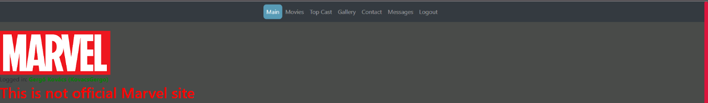

The menu is designed with controller and pattern design. I link to pages with ?page=. This information had to be set in the configuration file.



On the main page there is a little information about the Marvel movies, and underneath it is a picture where most of the characters are on it.

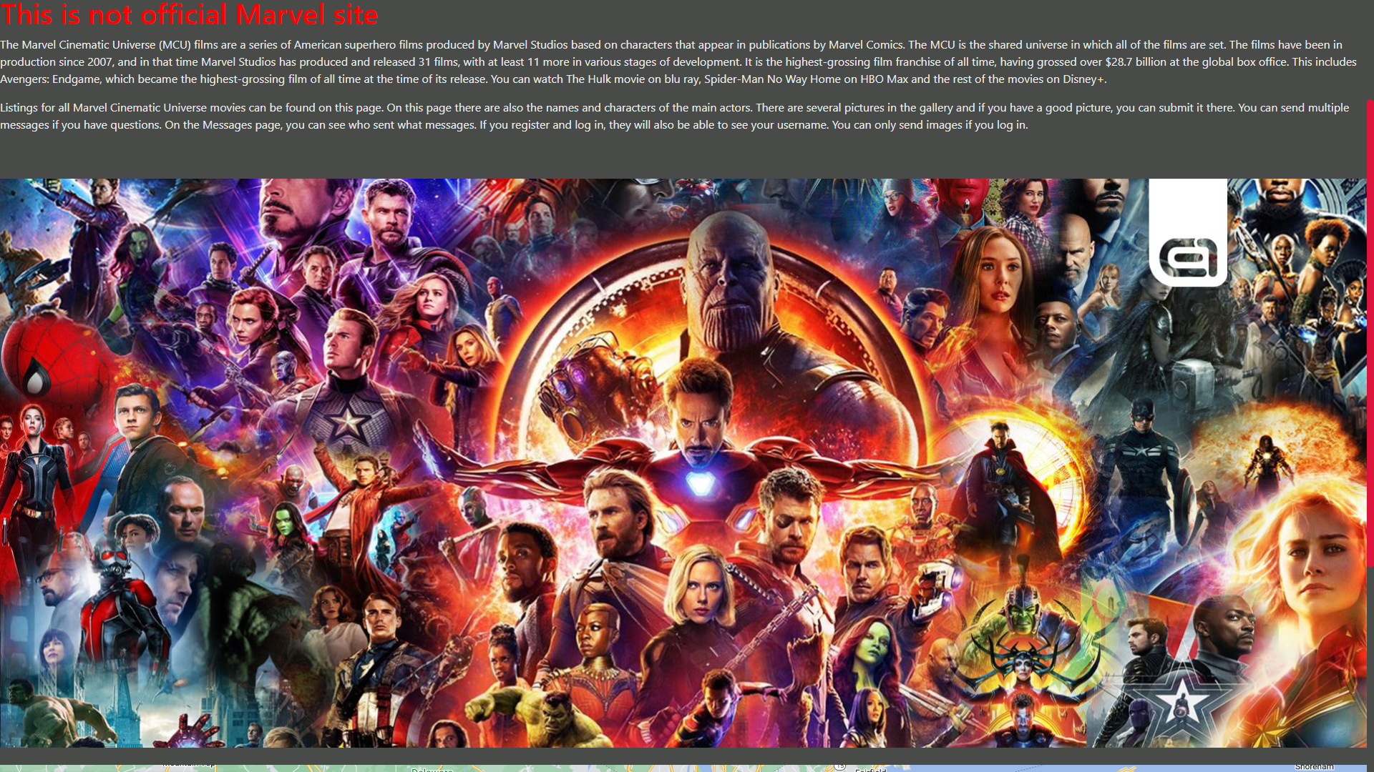

On the main page there is an introduction to the content of the page and a google map of New York, where many movies were set.

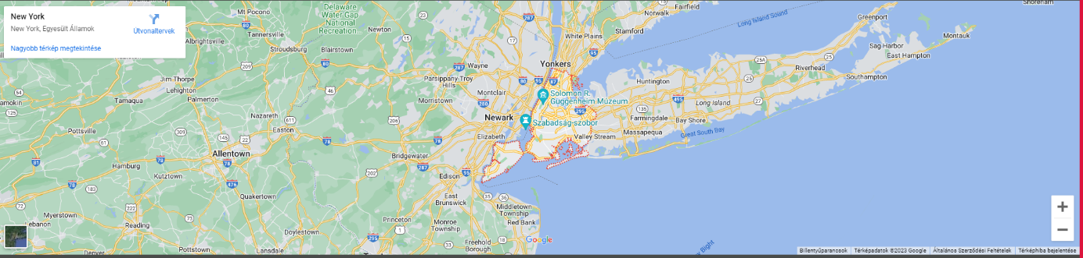

On the movies page, you can see profiles for all Marvel movies. Movies are grouped by phase. Hovering over the cover turns the image around and displays the data sheet text and images of the main characters in small.

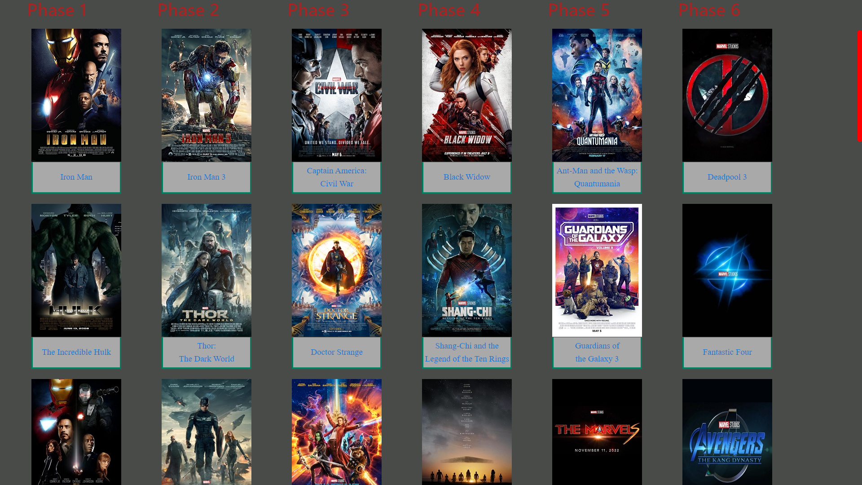

If we hover the mouse over the images, then the image will be turned over. You can see a description of the film and pictures with portraits of the main characters. If you hover your mouse over the portraits, the actor's name will appear.

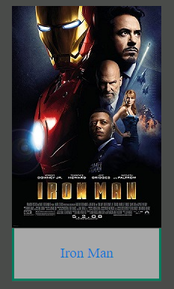

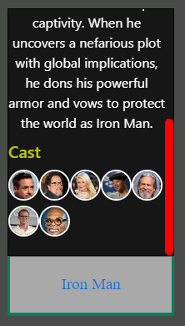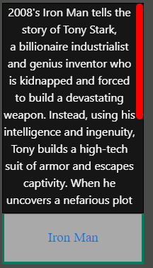

In the top cast menu there is a counter on the page, if you press the Start Worker button, it will start counting with the web worker. If you press the Stop Worker button, the count will stop and it will say Stoppped!

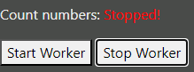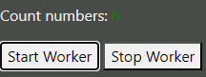

You can search for actors' names for characters. If it already finds matching letters, it will print out all the names found. If you click a name from the results, that field will have a black background color in the table.  
This is my Ajax site because I solved the search using XmlHttpRequest. I used an array where I entered the names of the characters. I also used these names as an index. I assigned an onclick event. The rows in the table also have an index, the name of the index has become the name of the character. It can only handle ids up to spaces, so you need to see if there is a space in the character's name. If it is in it, it will be detached at the space, if it is not, it will be the identifier of the Ajax live search engine.

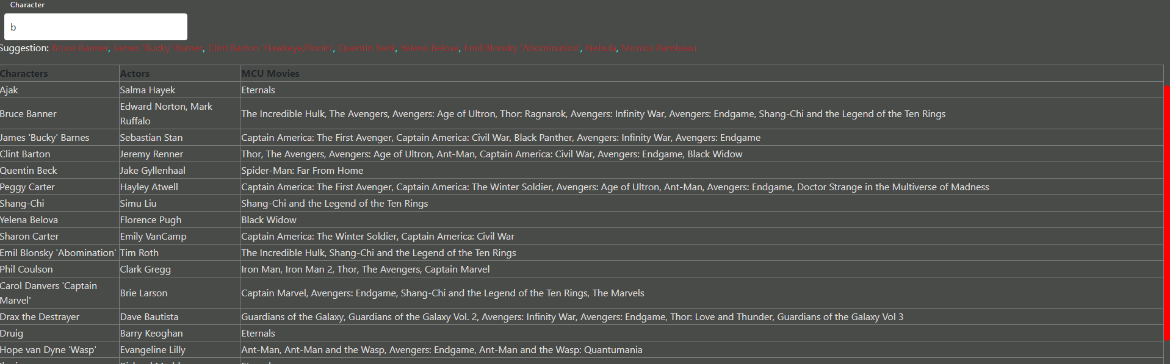

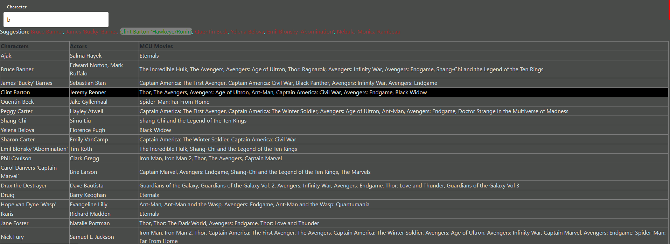



Below the table, you can see how many times the web page has been loaded by sessionstorage and localstorage.

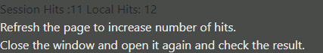

You can view images from Marvel movies on the gallery page. These images are also displayed on the page in chronological order. First in chronological order of your own images and then pictures sent by users.

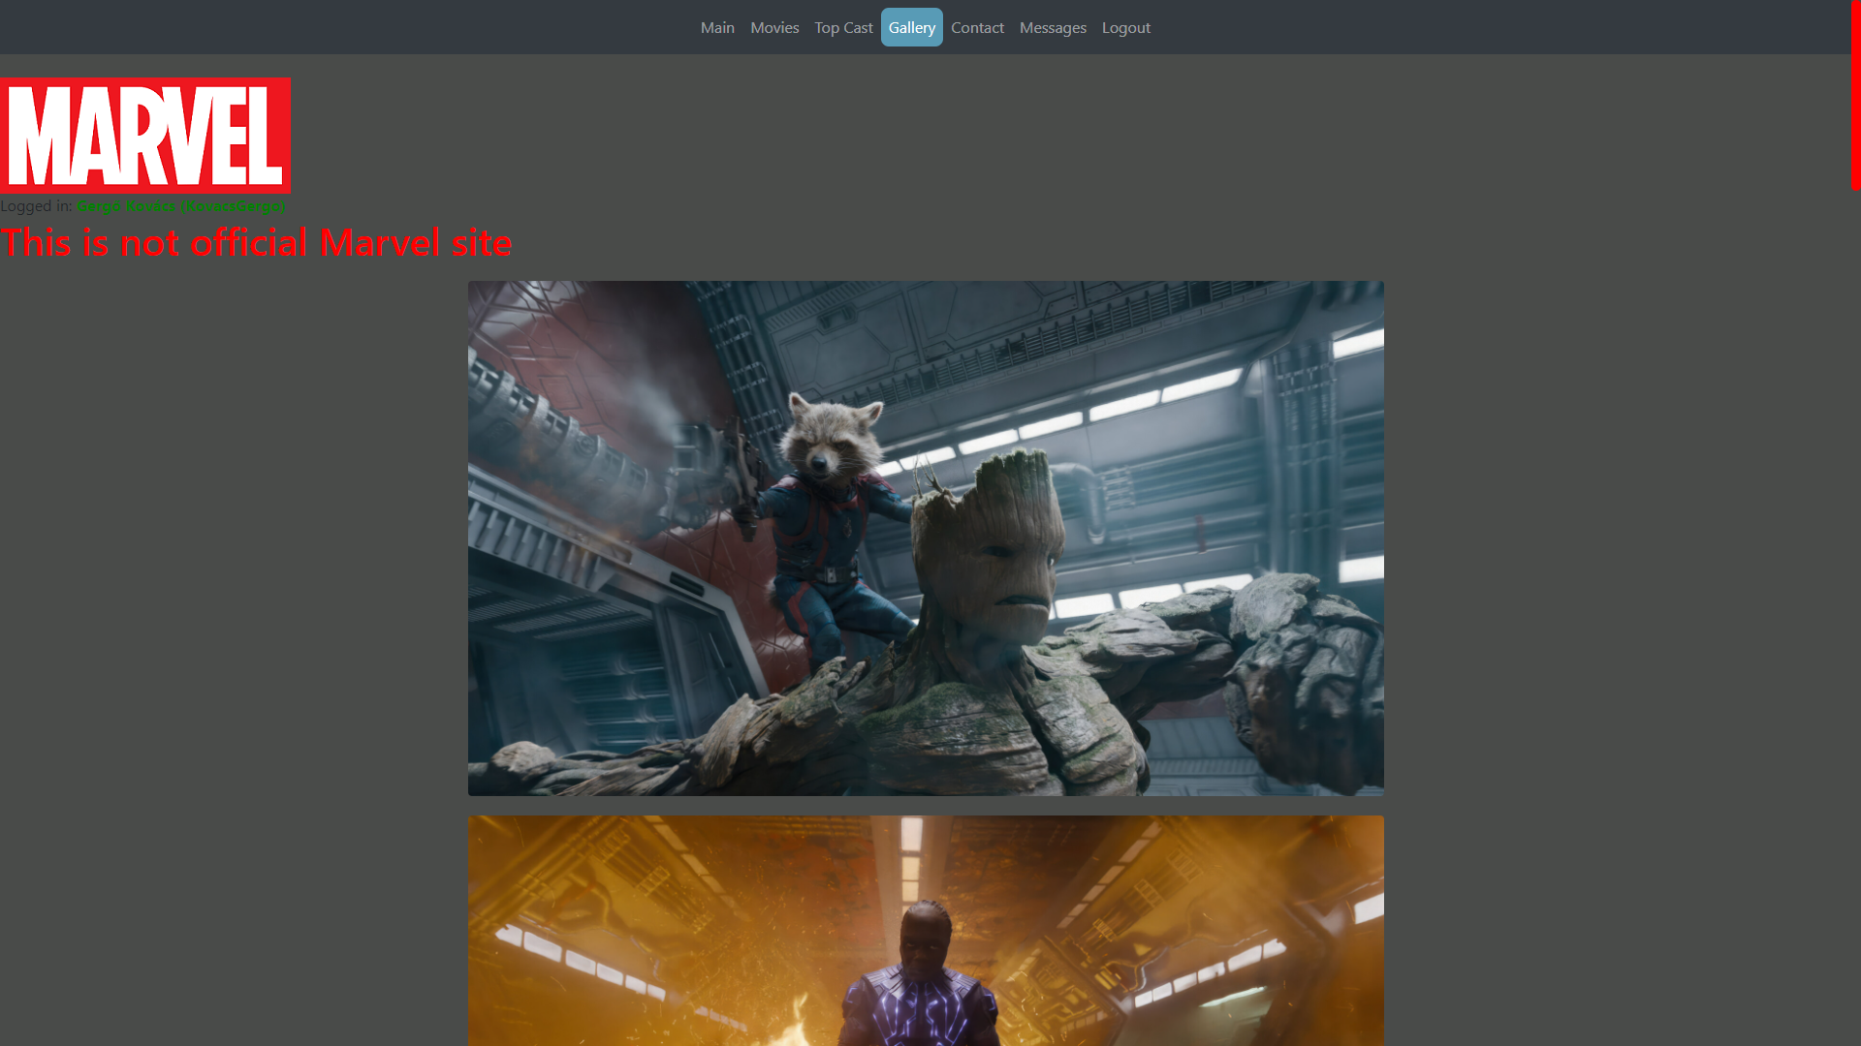

The last image is a canvas that the user can copy into the blank rectangle. There are two rectangles at the bottom of the page, and the user can put the Marvel logo from one to the other.

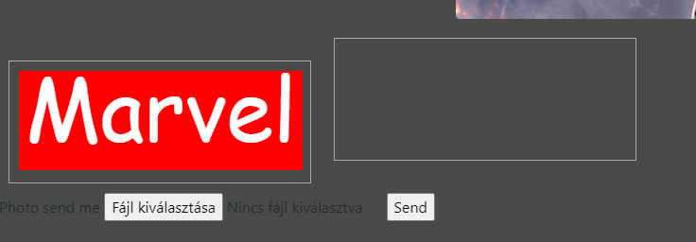

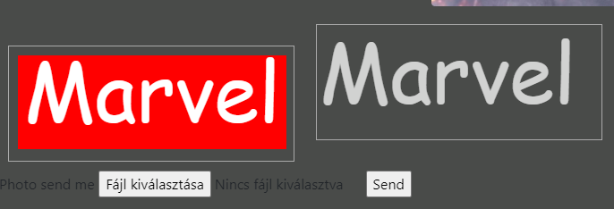

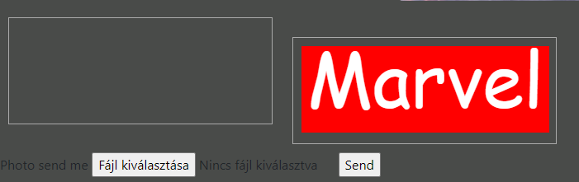

There are two folders where the pictures are located. In one folder are pictures that I found myself. The other folder contains images uploaded by the user.

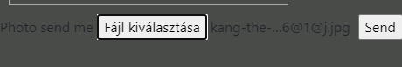

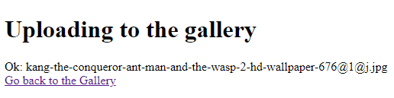

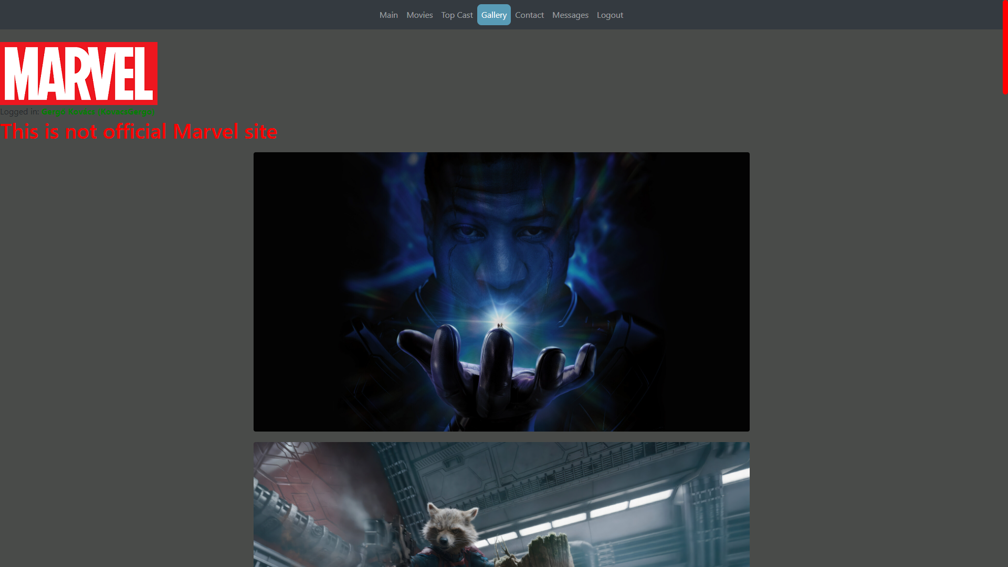

The upload folder displays the images uploaded by the users.

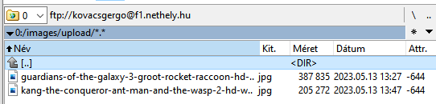

A user who is not logged on cannot send an image.

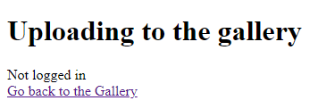

You cannot add a file that is too large.

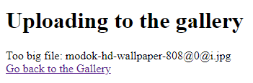

On the contact page, you can send an email via the send email link.



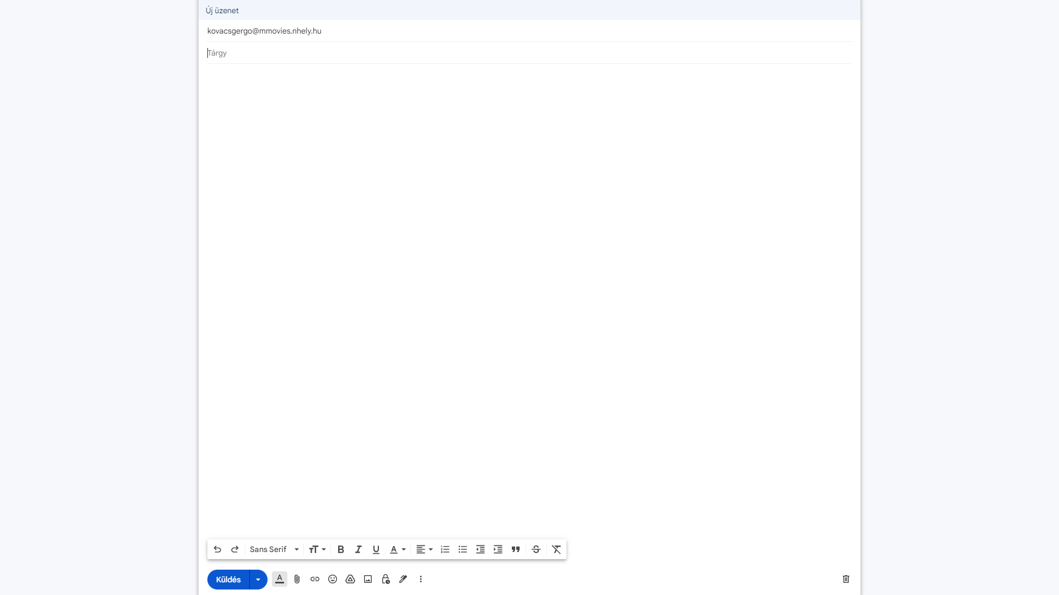

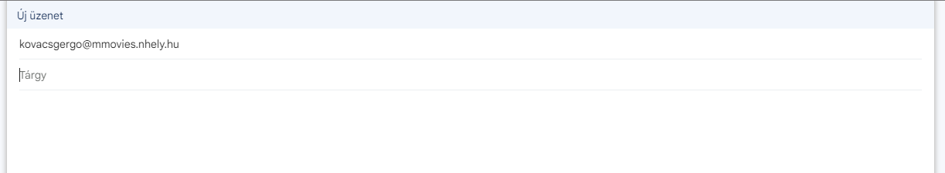

There are two forms on the site. You can send messages on one of the forms. On the other, the system can send a message.

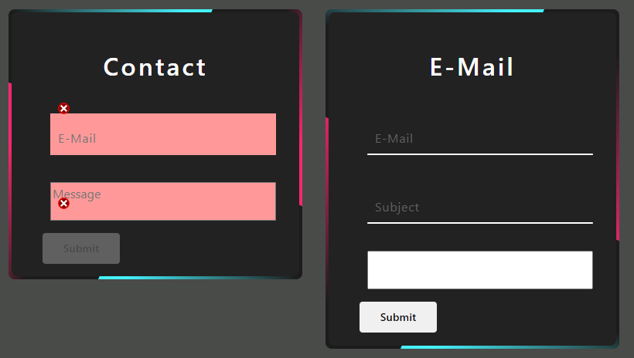

In the form called contact, you need to enter the email address and message. This will be checked by javascript and php.

By default, fields appear on a red background. Each field has an SVG image. The submit button is disabled until the conditions are good.

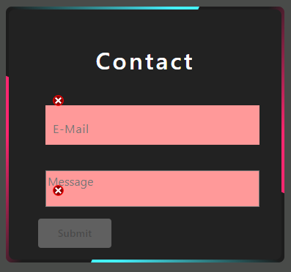

If there is a message in it and the e-mail address is correct, a green html icon will appear and the background color of the fields will also be green.

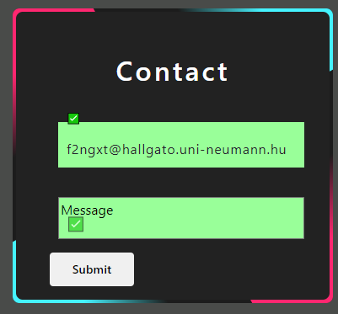

After pressing the button, the sent data will appear on another page.

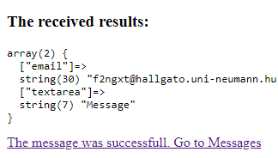

Going to phpMyAdmin, messages will appear in the messages table. The information sent by the user, the e-mail address and the message are displayed. The ID, username, and date of writing appear next to it.



If you are not logged in, you write guest instead of username.

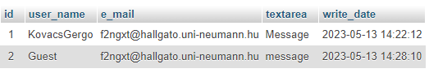

The email form can be used to send an email to the user. You must enter the email address, subject, and message.

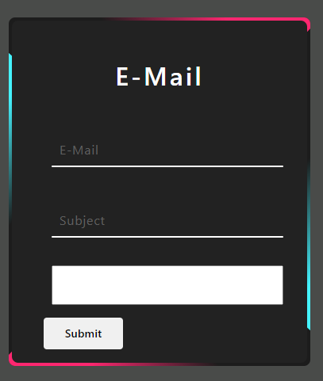

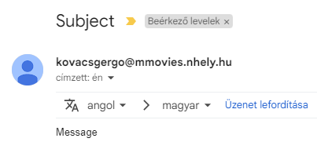

At the bottom of the page there is a button that you can press to query your coordinate and it will be placed on the google map.

A cookie appears on the messages page. Getting the username Kevin Feige.

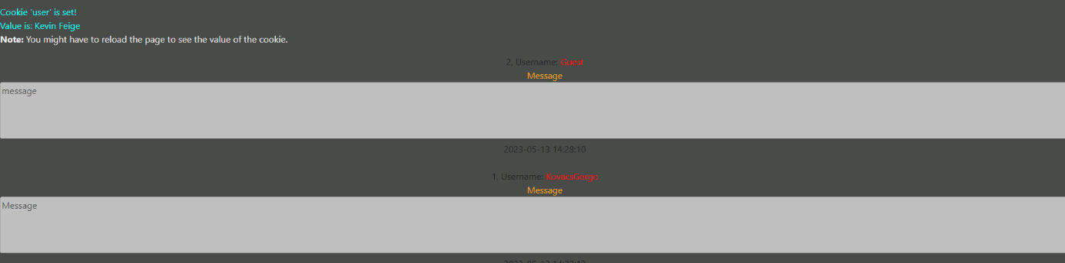

The messages page displays messages sent to the contact page.

If the message was sent by a logged-on user, it displays their user name; if they are not logged in, it displays the word „Guest”. It displays which day and at what hour, what minutes and seconds the message came. The most recent messages appear at the top and the oldest messages appear at the bottom.

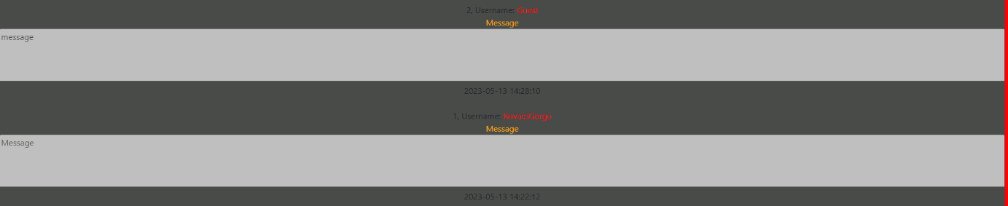

Under the messages, you will see that the server updates itself and continuously displays the current date.

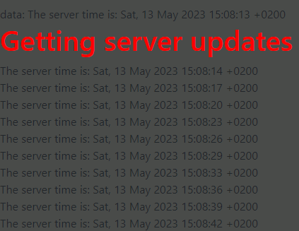

The last item in the menu is the registration/login/logout page.

If the user is not logged in, Login is, if you're signed in, you'll see Logout.



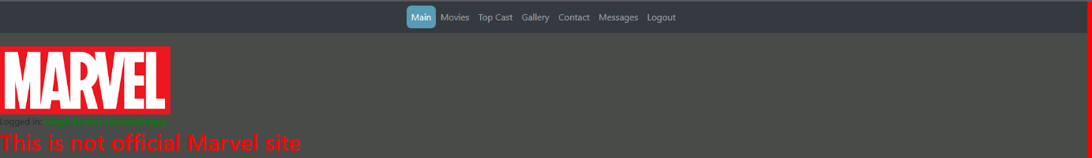

If you are not logged in, clicking on Login opens the login and registration page.

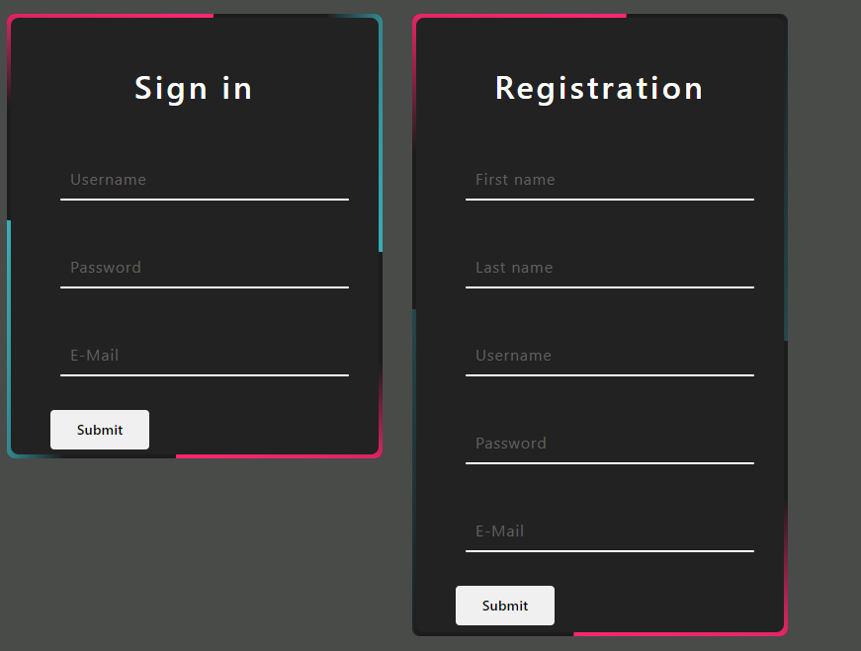

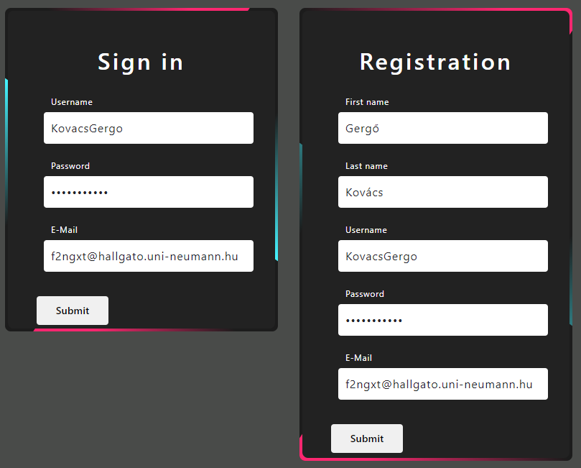

I store user data in the database. The password field is stored with SHA1 encryption to keep your data safe.



Request the data after checking the HTML. If you already have a username or email address, we will not allow you to register on the site.





After successful sign-in, it displays the user's login ID and full name. If you are logged in, your login details will remain after you leave the site and you will not have to log in next time.

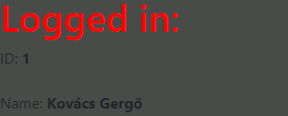

Clicking Sign out logs the user out. It displays your full name and username.



I also used sass, there I specified the colors of the paragraph and span tag.

At the bottom of all pages in the footer is the copyright and current year.



The page contains a bootstrap, making the site responsive.

Content from your phone.

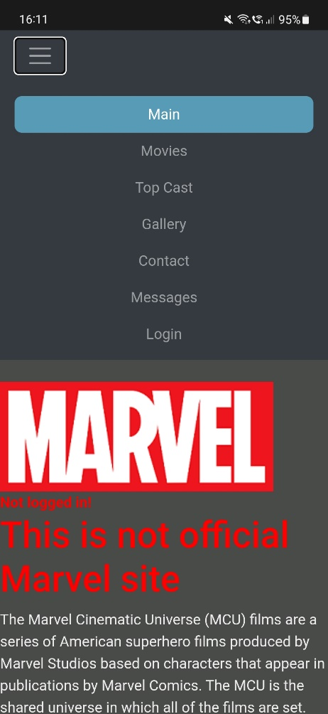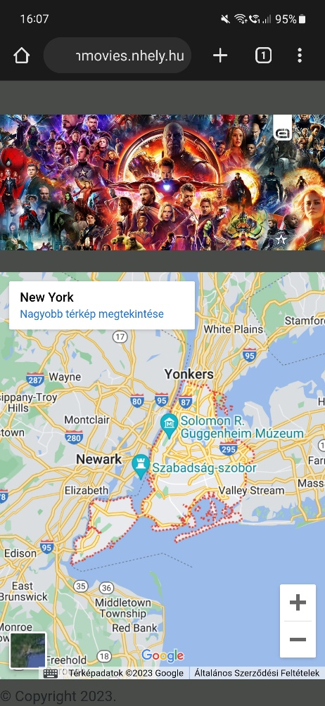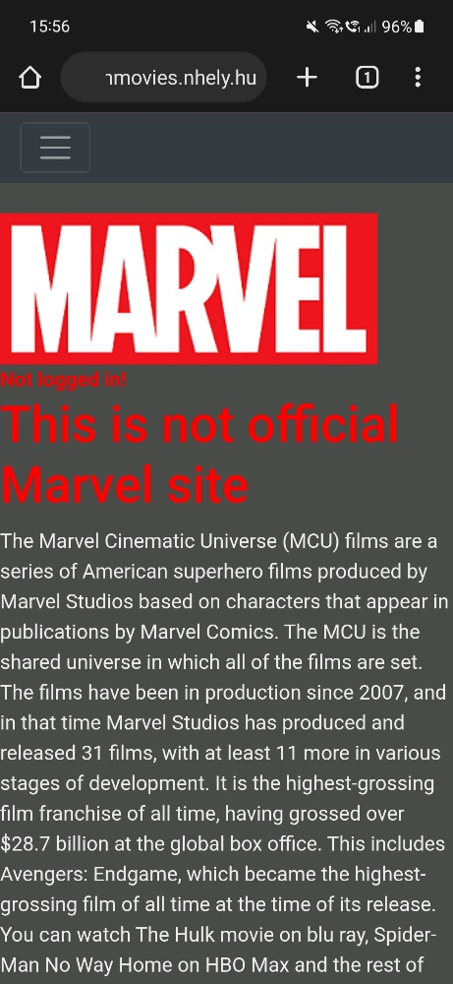The menu from the phone has already become a list. The image and map adjust to fit the size of your phone.

The films are placed one below the other, centered. If we touch the image, it turns around and we can see the information.

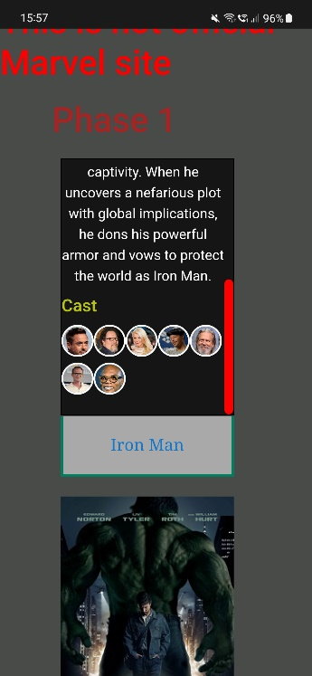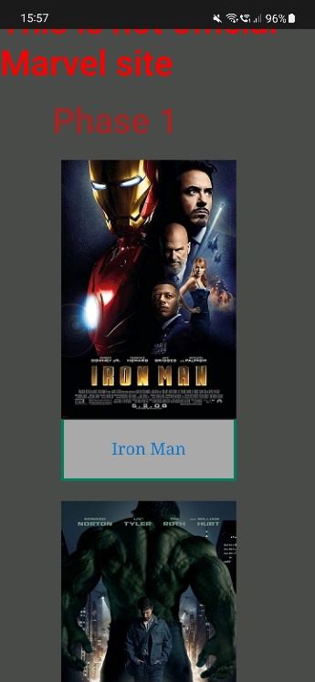

The last column of the table has been moved to several rows, so it fits on your phone. Features work here too. You can search for characters in the same way, and the row of the selected item will have the same black background.

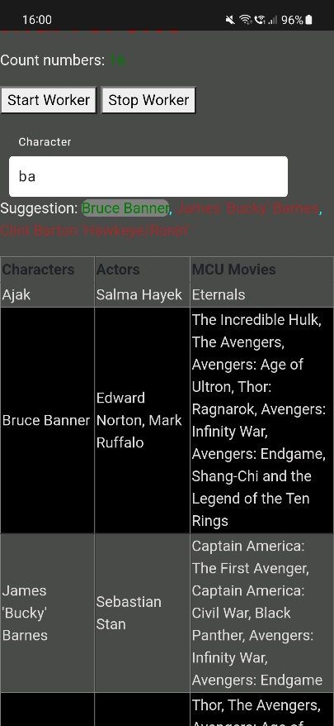

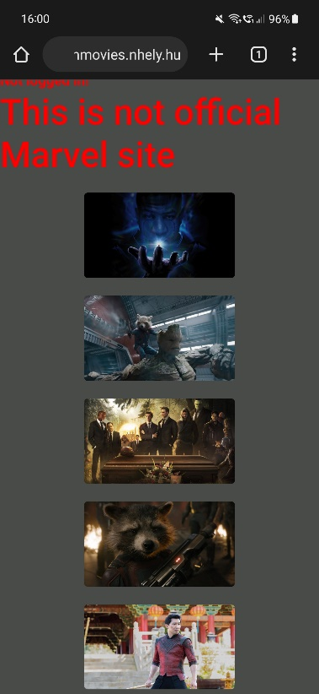Images appear centered in the center of the page.

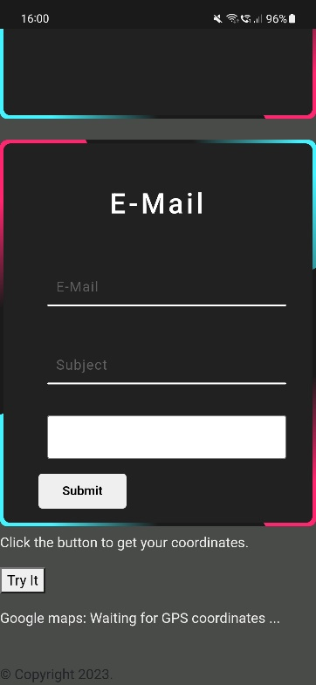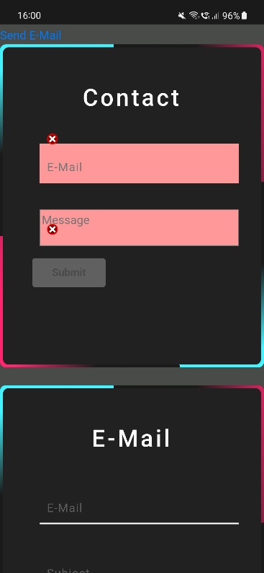On the contact page, the two forms appear one below the other. This allows it to fit across the entire width of the page.

The messages box is full-width readable.

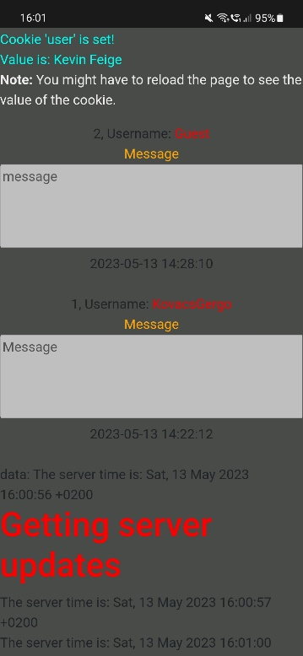

The registration and login forms are placed one below the other, so they have enough width to fit on the page.

